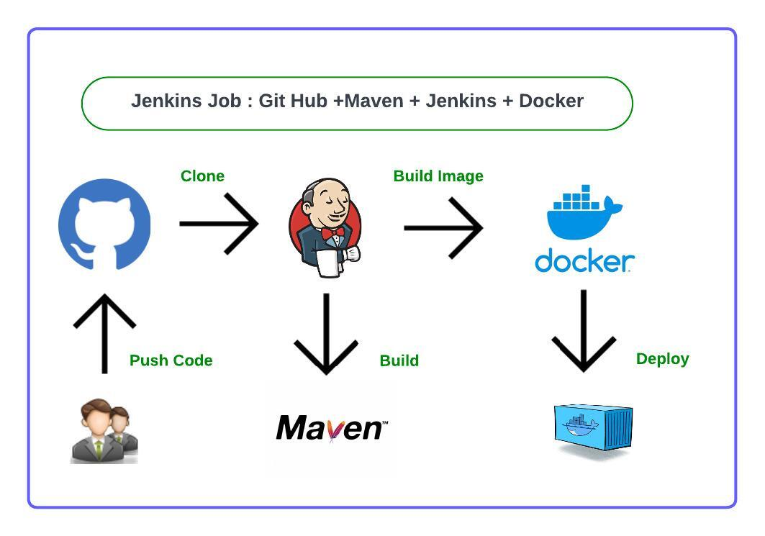

**Prerequisite tools for creating the Jenkins project**

* Linux machine
* Maven
* Git Hub
* Jenkins
* Docker

# Step-1 : Jenkins Server Setup in Linux VM

1. Create Ubuntu VM using AWS EC2 (t2.medium)
2. Enable 8080 Port Number in Security Group Inbound Rules
3. Connect to VM using MobaXterm
4. Install Java
5. Install Jenkins
6. Jenkins to be installed, start Jenkins, verify Jenkins, Access jenkins server in browser using VM public ip - <http://public-ip:8080/>, Copy jenkins admin pwd, Create Admin Account & Install Required Plugins in Jenkins

# Step-2 : Configure Maven as Global Tool in Jenkins

## **Step-3 : Setup Docker in Jenkins**

# Step - 4 : Create Jenkins Job

# Step - 5 : Trigger Jenkins Job

# Step - 6 : Enable host port in security group inbound rules

# Step - 7 : Access Application in Browser

## **Step - 8 : After your practise, delete resources we have used in AWS Cloud to avoid billing**

# 